Data Visualization & Machine Learning
─────────────────────────────────────────
Field | Details
Subject | Data Science & Machine Learning
Topic | Matplotlib, Seaborn & ML Models
Q1 | Matplotlib vs Seaborn — Features, Graphs (10 Common + 10 Different)
Q2 | Classification vs Regression vs Clustering
Q3 | ML Models with Custom Dataset (up to Accuracy)
Font Size | 12pt — Times New Roman
Submitted By | Fareeha kanwal

Question 1: Matplotlib and Seaborn — Complete Study

1.1 Common Features Between Matplotlib and Seaborn
Matplotlib and Seaborn are both Python data visualization libraries that share extensive common ground. Because Seaborn is built directly on top of Matplotlib, every Seaborn plot ultimately uses Matplotlib's rendering engine. This relationship means that almost all customizations available in Matplotlib also apply to Seaborn figures.

A. Shared Plot Types
Both libraries natively support all fundamental chart types used in data analysis: line plots, scatter plots, bar charts, histograms, box plots, heatmaps, violin plots, area plots, and error bar plots. These plot types cover the vast majority of visualization needs in academic and professional data science work.
B. Matplotlib Axes Compatibility
Every Seaborn function returns a standard Matplotlib Axes object. This means after any sns.* call, all Matplotlib customization functions — plt.title(), plt.xlabel(), plt.ylabel(), plt.xlim(), plt.xticks(), plt.legend(), plt.savefig() — apply directly without any compatibility issues. The two libraries can be freely mixed within a single script or notebook.
C. Figure and Multi-Panel Layouts
Both libraries use the same plt.subplots() system for creating grids of panels. You can create a 2×3 grid with fig, axes = plt.subplots(2, 3) and pass individual Axes to Seaborn's ax= parameter. This enables complex dashboards that combine both libraries side by side in a single figure.
D. Color Palettes and Colormaps
Both libraries support custom color palettes and colormaps. Matplotlib uses its cmap system (e.g., 'viridis', 'coolwarm', 'plasma'), while Seaborn adds its own named palettes (e.g., 'muted', 'deep', 'Set2') which internally translate to Matplotlib color cycles. Both accept named colors, hex codes, and RGB tuples.
E. Figure Size, DPI, and Export
Both libraries use plt.figure(figsize=(width, height)) and plt.savefig('file.png', dpi=300) for size control and export. The figsize parameter and dpi setting apply to the figure as a whole regardless of which library drew the plot content inside it.
F. Axis Labels, Titles, and Annotations
Titles, axis labels, tick marks, grid lines, legends, and text annotations work identically for plots from both libraries. Functions like ax.set_title(), ax.set_xlabel(), ax.annotate(), ax.text(), and ax.axhline() can be applied to any plot produced by either library.

Common Feature | Matplotlib Function | Seaborn Function
Line, Bar, Scatter, Box, Histogram | Yes | Yes
Heatmap | plt.imshow() | sns.heatmap()
Violin Plot | plt.violinplot() | sns.violinplot()
Error Bar | plt.errorbar() | sns.pointplot()
Color control | cmap= / color= | palette= / hue=
Figure size | figsize=(w,h) | figsize=(w,h)
Export | plt.savefig() | plt.savefig()
Multi-panel layout | plt.subplots() | plt.subplots() + ax=
Axis customization | plt.xlabel() etc. | plt.xlabel() etc.
Legend | plt.legend() | plt.legend()

1.2 Different Features Between Matplotlib and Seaborn
Despite their shared foundation, Matplotlib and Seaborn differ significantly in abstraction level, default aesthetics, statistical capabilities, and the unique plot types each provides. These differences determine which library is the better choice for a given visualization task.

Feature | Matplotlib | Seaborn
Abstraction level | Low-level — full manual control | High-level — smart defaults
Data input | NumPy arrays / Python lists | Pandas DataFrame preferred
Statistical features | None — must code manually | Built-in CI, KDE, regression
Default aesthetics | Plain white background | Polished with grid and palette
Grouping by color | Manual color list + loop | hue= parameter (one word)
Error bars | Manually set yerr= | Automatically computed
KDE overlay | Separate scipy computation | kde=True in histplot
Regression line | Manual np.polyfit() | sns.regplot() one call
Pair plots | Write nested loops (~30 lines) | sns.pairplot() one call
Categorical plots | Basic bar only | boxplot, violin, strip, swarm, point
FacetGrid | Not available | sns.FacetGrid() built-in
Count plot | value_counts() + plt.bar() | sns.countplot() one call
Pie chart | plt.pie() available | Not available natively
Stem plot | plt.stem() available | Not available
3D plotting | mpl_toolkits.mplot3d | Not available
Animation | matplotlib.animation | Not available
Clustermap | Not available | sns.clustermap() built-in

1.3 Why We Use Seaborn Instead of Matplotlib
Seaborn is preferred over pure Matplotlib in data science and exploratory data analysis (EDA) because it eliminates repetitive low-level coding and provides statistical visualizations in single function calls. The following reasons explain the preference for Seaborn.

A. Beautiful Defaults Without Extra Code
Seaborn's default theme is significantly more attractive than Matplotlib's plain style. Simply importing Seaborn elevates all subsequent plots. The default color palette, font sizes, grid style, and spacing are all professionally chosen without any manual configuration needed.
B. Statistical Visualizations in One Line
Seaborn integrates statistics directly. sns.histplot(data=df, x='age', kde=True) draws a histogram with a kernel density estimate in one call. sns.regplot() draws a scatter with regression line and confidence band automatically. These features require 15–20 extra lines in pure Matplotlib.
C. Native Pandas DataFrame Support
Seaborn accepts Pandas DataFrames and references columns by name: x='column_name'. This eliminates extracting arrays before plotting and makes code far more readable. Matplotlib requires df['column'].values or similar array extraction.
D. Automatic Grouping with hue=
The hue= parameter automatically splits data into groups, assigns distinct colors, and creates a legend — all in one line. Matplotlib requires a for loop, manual color selection, separate plot calls per group, and manual legend construction to achieve the same result.
E. Complex Statistical Plots Simplified
Plots like sns.pairplot(), sns.clustermap(), FacetGrid, and violin plots are trivially easy in Seaborn but extremely difficult in Matplotlib. sns.pairplot(df, hue='species') creates a complete matrix of scatter plots colored by category in a single call — equivalent to ~30+ lines in Matplotlib.

Task | Matplotlib | Seaborn
Histogram with KDE | ~12 lines | 1 line (kde=True)
Grouped scatter plot | ~8 lines (loop needed) | 1 line (hue=)
Box plot with groups | ~6 lines | 1 line
Regression line + CI | ~15 lines | 1 line (sns.regplot)
Pair plot matrix | ~30+ lines | 1 line (sns.pairplot)
Count plot | Manual count + bar | 1 line (sns.countplot)
Apply theme | Multiple rcParams | sns.set_theme() one call

1.4 Why We Use the Combination of Matplotlib and Seaborn
The most powerful approach is to use both libraries together: Seaborn handles statistical complexity and attractive defaults, while Matplotlib provides fine-grained customization and unique plot types not available in Seaborn.

A. Adding Custom Annotations After Seaborn
After drawing a Seaborn distribution plot, you can add reference lines, arrows, and text using Matplotlib's ax.axvline(), ax.annotate(), and ax.text(). This is standard practice in research papers — draw the distribution in Seaborn, then annotate critical values in Matplotlib.
B. Using Pie and Stem Plots Alongside Seaborn
Seaborn cannot produce pie charts or stem plots. In a mixed dashboard, you draw most plots using Seaborn's high-level API and then add pie charts or stem plots using Matplotlib's dedicated plt.pie() and plt.stem() functions on separate subplot axes.
C. Fine-Grained Axis and Tick Control
Seaborn does not expose every axis formatting option. When you need precise tick positions, tick label rotation, secondary y-axes, or log scales, you use Matplotlib functions after the Seaborn call. Example: sns.barplot(...) followed by plt.xticks(rotation=45) and plt.ylim(0, 100).
D. Global Style via rcParams
Matplotlib's rcParams system controls global defaults — font family, font size, line width, figure DPI — that apply to all subsequent plots including Seaborn ones. Combining sns.set_theme() with custom plt.rcParams updates gives complete control over the visual identity of an entire report or paper.
E. Example Combined Workflow
A typical combined workflow: (1) sns.histplot(data=df, x='score', kde=True) draws the base distribution. (2) plt.title('Score Distribution') sets the title. (3) plt.axvline(x=df['score'].mean(), color='red', linestyle='--') adds a mean reference line. (4) plt.savefig('plot.png', dpi=300) exports it. Each step uses the most appropriate tool.

1.5 Ten Common Graphs in Matplotlib and Seaborn
The following ten graph types are natively supported by both Matplotlib and Seaborn. Each entry identifies the appropriate data type, provides a detailed description, and shows the rendered graph output alongside the complete Python program for both libraries in a side-by-side VS Code editor screenshot.

1. Line Plot
Data Type: Continuous numerical data — time-series, sequential measurements
A line plot connects ordered data points with a straight or curved line, making it the primary chart for visualising trends, changes over time, or sequential relationships. It is suitable when the x-axis represents time or an ordered sequence. Matplotlib uses plt.plot() with manual label and grid setup. Seaborn's sns.lineplot() automatically adds column-name labels and draws a shaded confidence interval band when multiple y-values exist per x value.

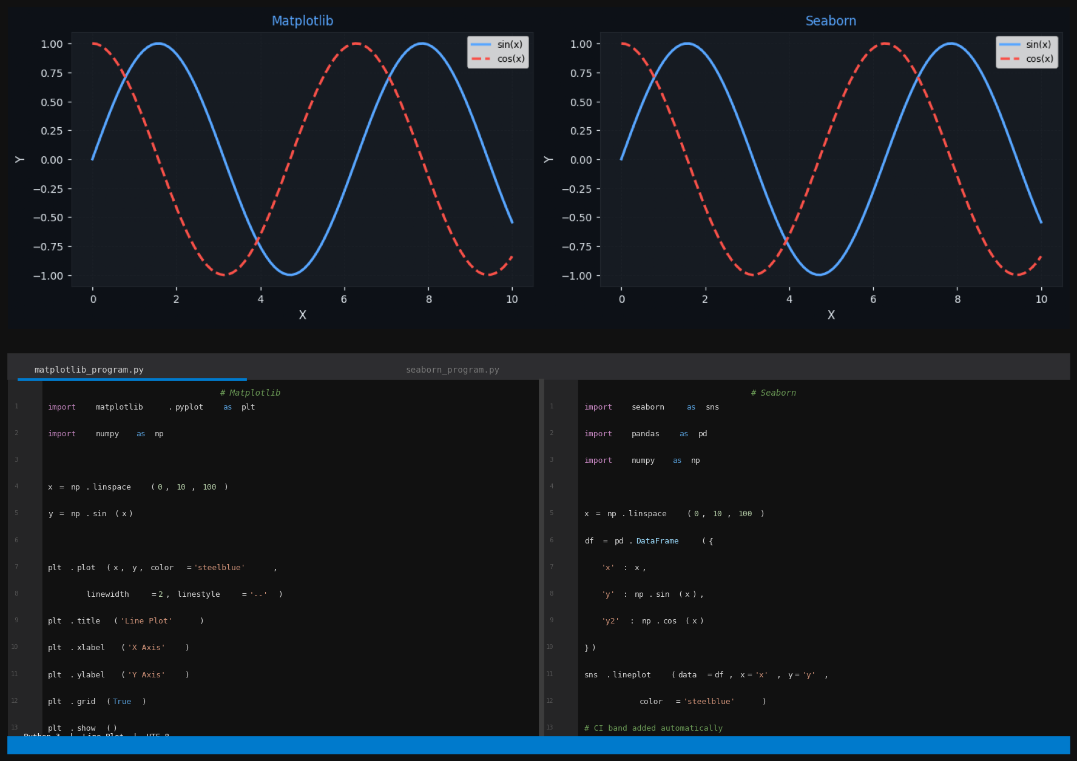
Figure 1: Line Plot — Graph output (top) with Matplotlib program (bottom-left) and Seaborn program (bottom-right)

2. Bar Chart
Data Type: Categorical data — discrete groups compared by a numerical measure
A bar chart displays categorical data as rectangular bars whose height represents the value of each category. It is the most widely used chart for comparing quantities across distinct groups. Matplotlib's plt.bar() requires manually pre-calculated error values (yerr=). Seaborn's sns.barplot() computes and draws 95% confidence interval error bars automatically from raw data, and the hue= parameter groups bars side-by-side with no additional code.

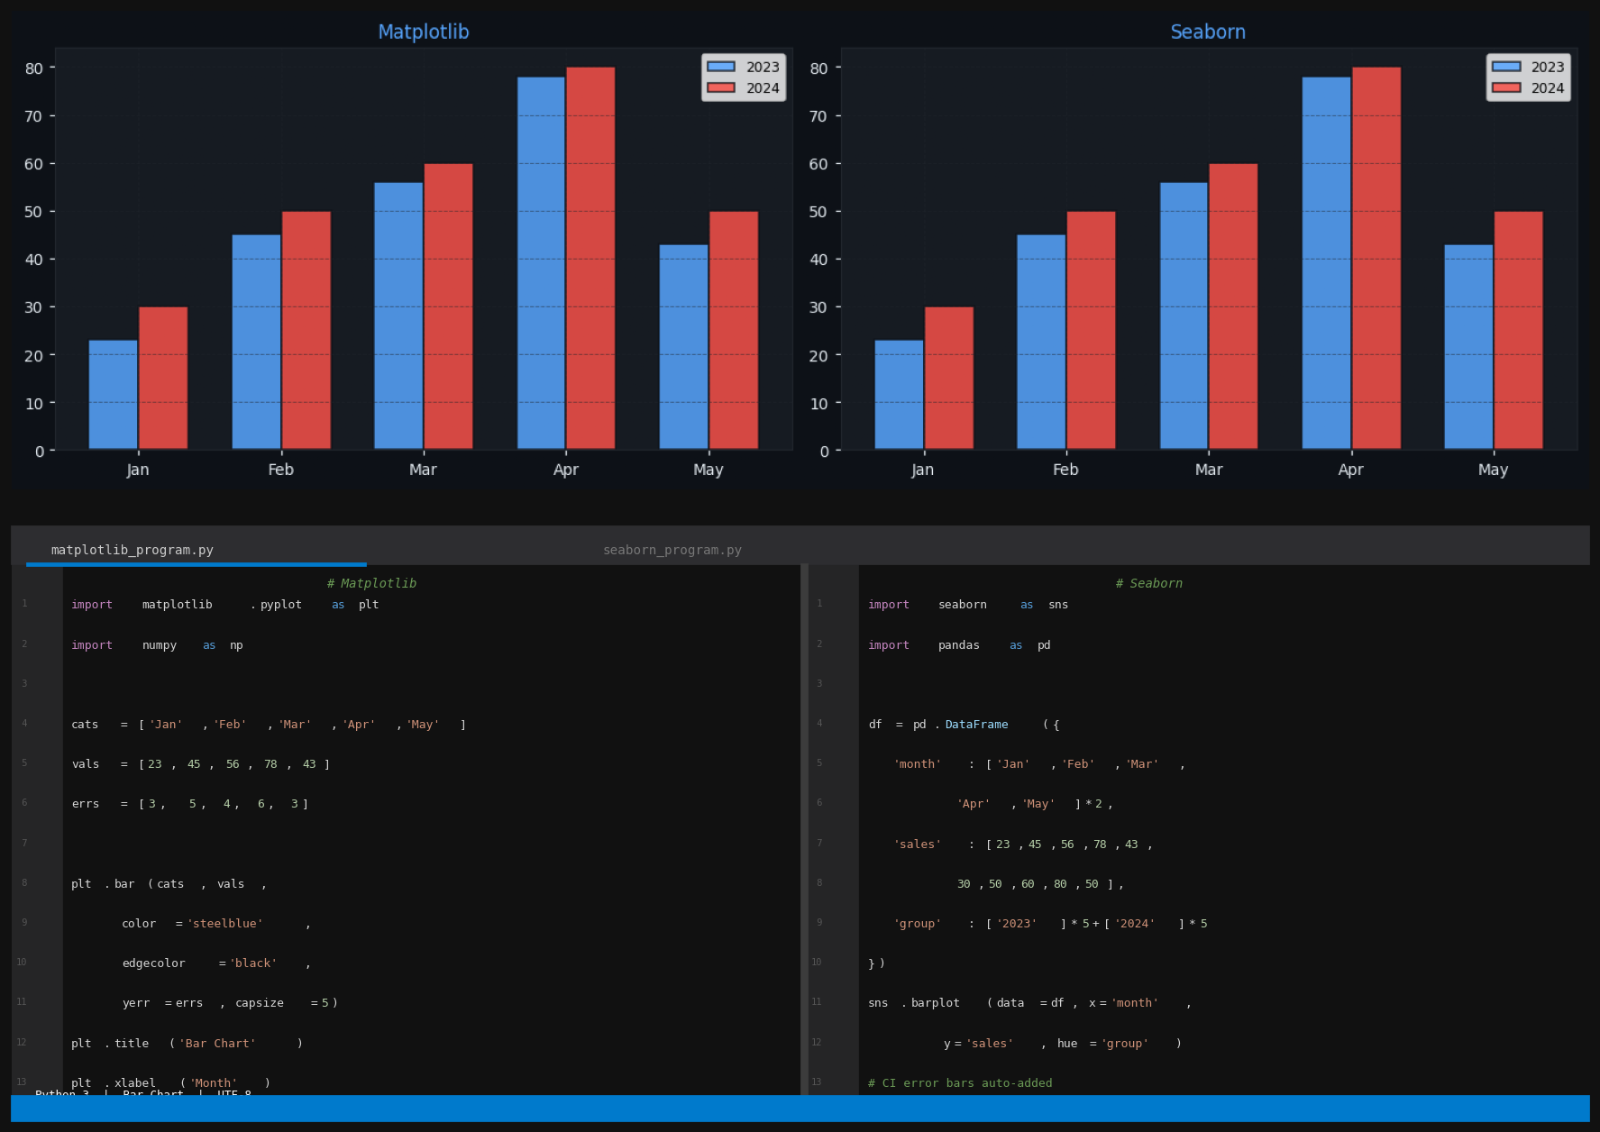
Figure 2: Bar Chart — Graph output (top) with Matplotlib program (bottom-left) and Seaborn program (bottom-right)

3. Scatter Plot
Data Type: Two continuous numerical variables — correlation, clustering, outlier detection
A scatter plot places dots at (x, y) coordinate pairs and is the primary tool for examining the relationship between two numerical variables. It reveals linear or non-linear correlations, natural clusters, and outliers. Matplotlib requires a manual color list and loop for grouping. Seaborn's hue= parameter automatically maps categories to distinct colors and builds a legend, and size= scales marker size by a third variable in one parameter.

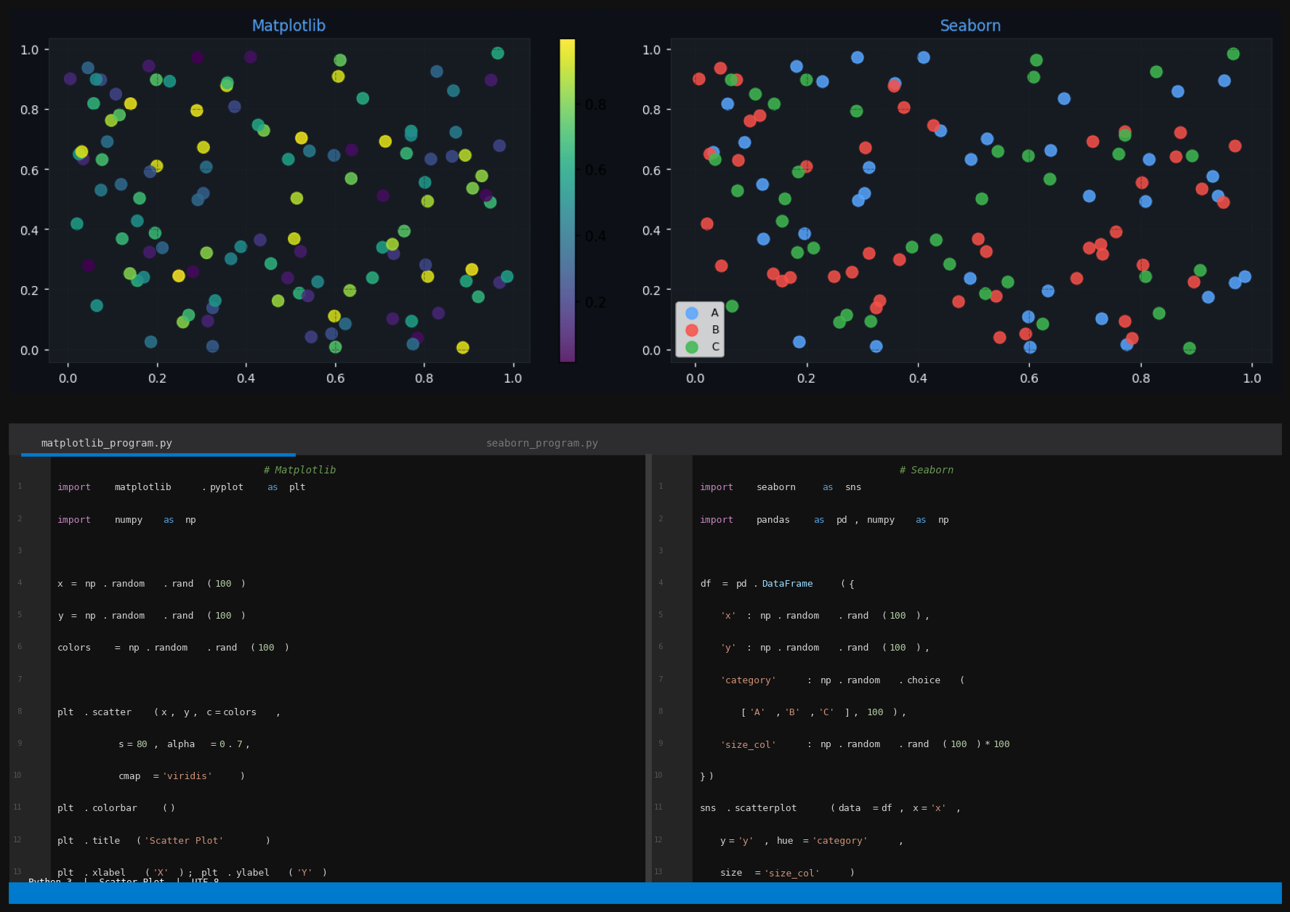
Figure 3: Scatter Plot — Graph output (top) with Matplotlib program (bottom-left) and Seaborn program (bottom-right)

4. Histogram
Data Type: Single continuous numerical variable — frequency distribution, spread
A histogram divides a continuous variable into equal-width bins and counts observations in each bin, revealing the underlying frequency distribution. Essential for understanding data spread, skewness, and modality before any modelling. Matplotlib's plt.hist() requires a separate scipy.stats computation and plot call to add a KDE overlay. Seaborn's sns.histplot() with kde=True overlays the smooth kernel density estimate curve in a single parameter.

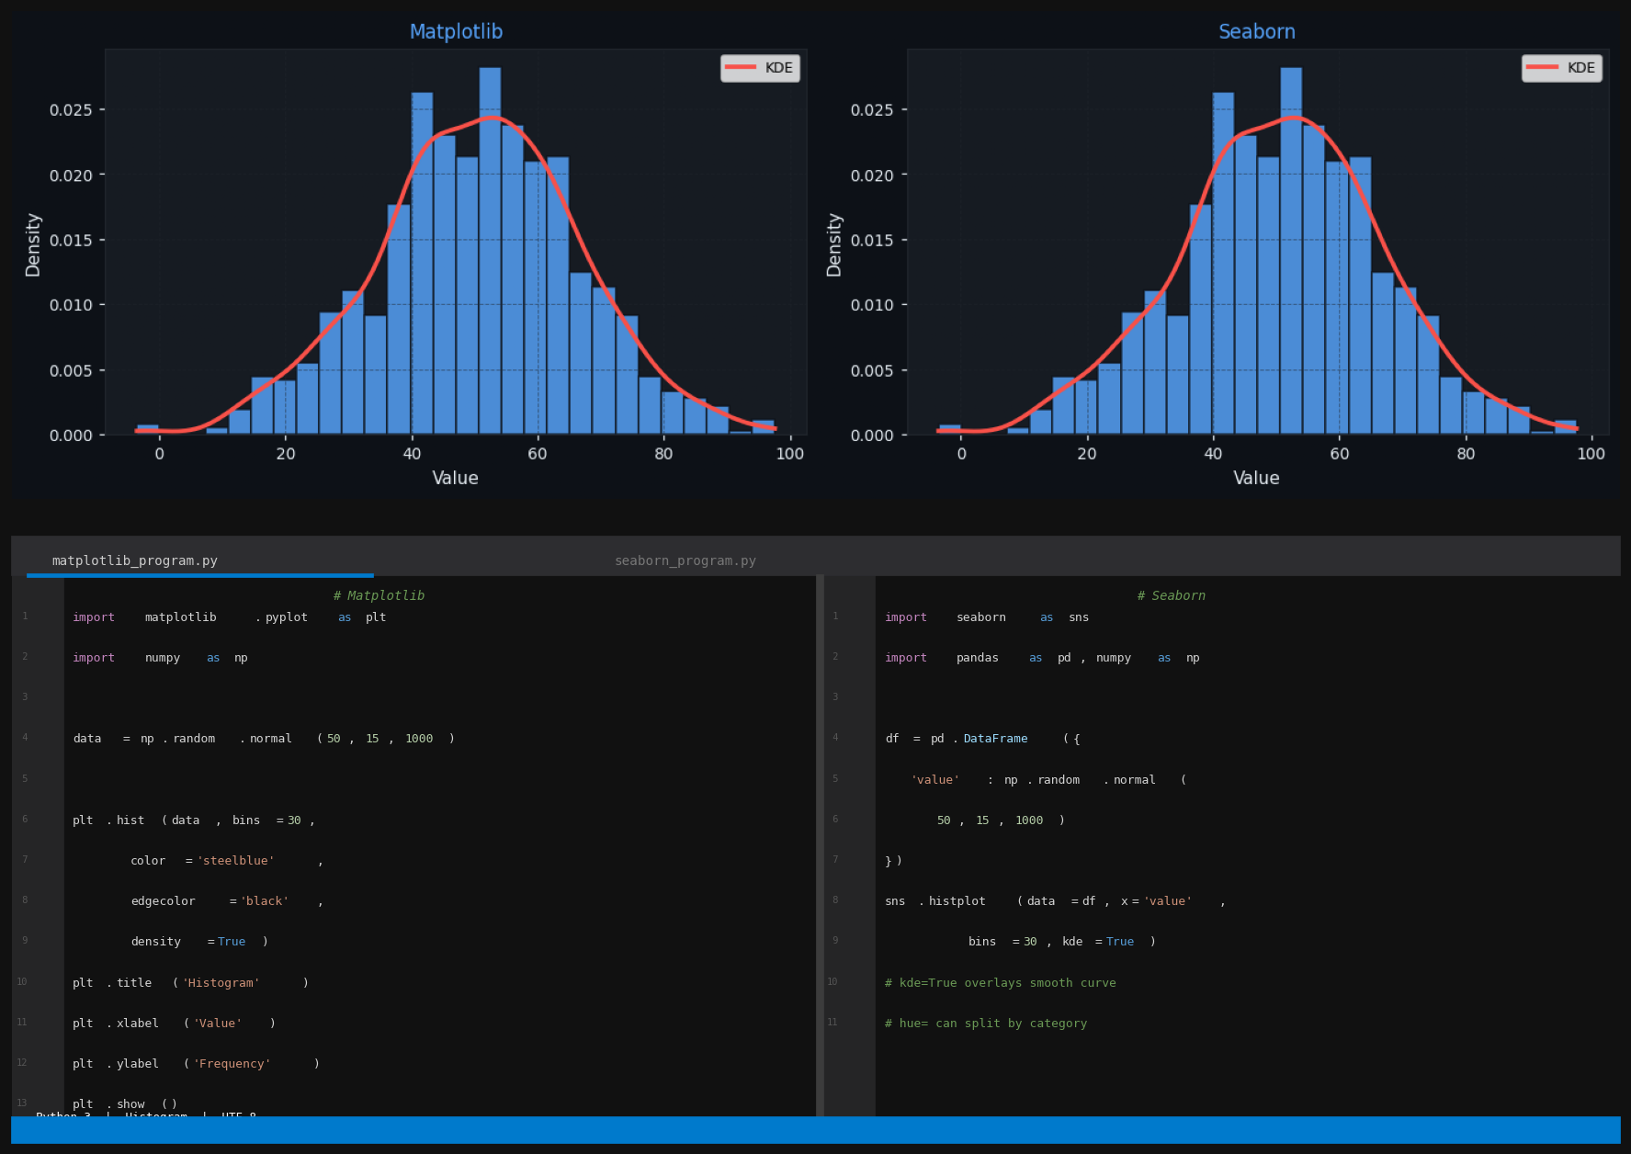
Figure 4: Histogram — Graph output (top) with Matplotlib program (bottom-left) and Seaborn program (bottom-right)

5. Box Plot
Data Type: Continuous numerical grouped by category — statistical summary
A box plot (box-and-whisker) summarises a distribution using five statistics: minimum, Q1, median, Q3, and maximum. Points beyond 1.5 × IQR are plotted as individual outlier dots. Enables instant comparison of central tendency, spread, and skewness across groups. Matplotlib requires data as a list of arrays and needs patch_artist=True to fill boxes with colour. Seaborn reads directly from a tidy DataFrame column and fills boxes automatically.

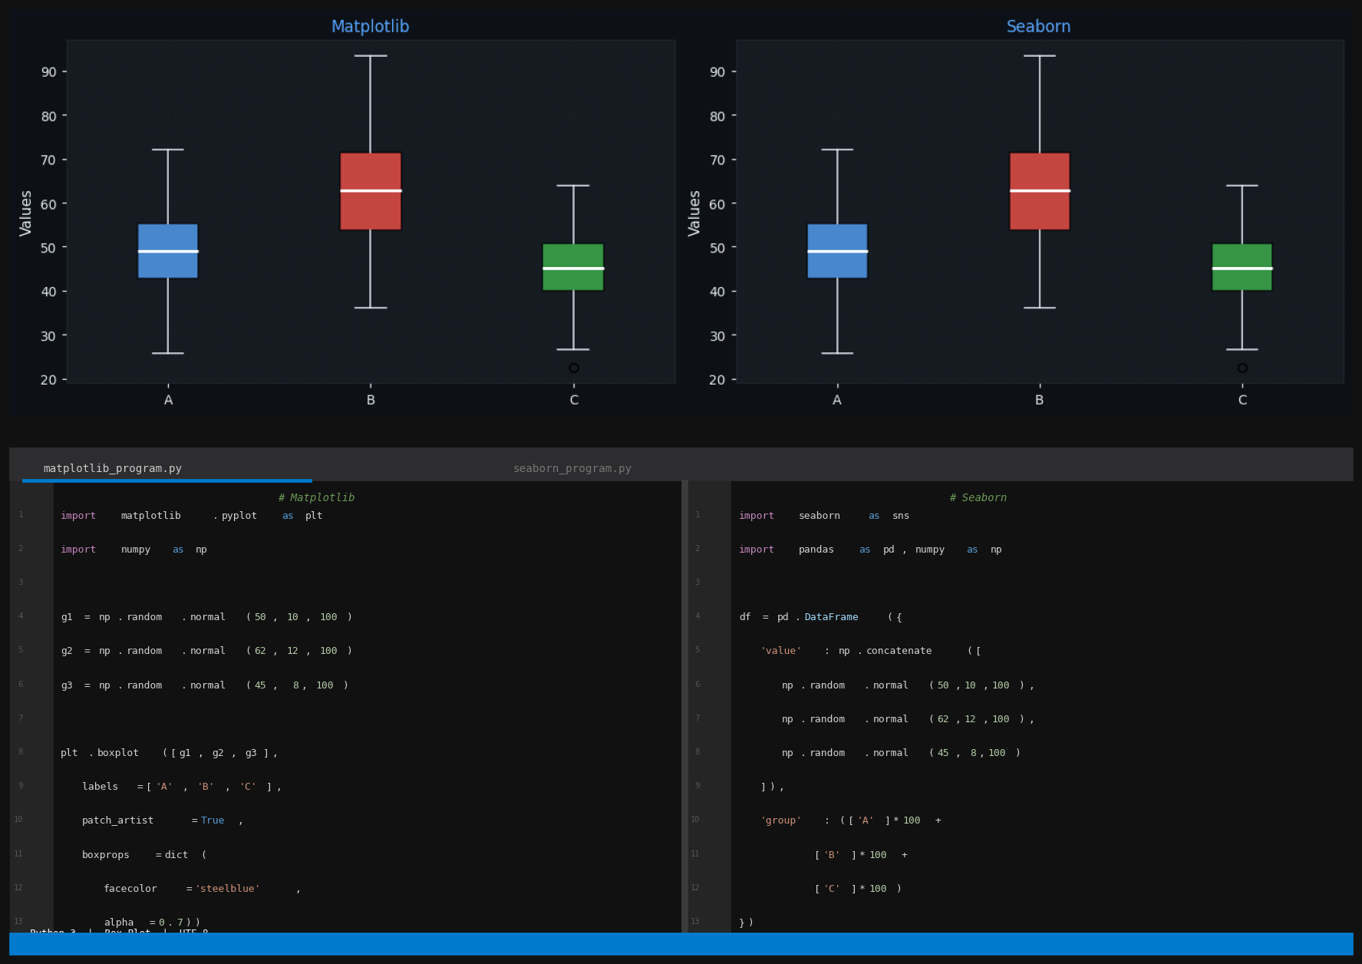
Figure 5: Box Plot — Graph output (top) with Matplotlib program (bottom-left) and Seaborn program (bottom-right)

6. Heatmap
Data Type: 2D matrix of numerical values — correlation, frequency, activity grids
A heatmap encodes numerical values in a two-dimensional grid using colour intensity, making it ideal for correlation matrices, confusion matrices, and weekly activity patterns. Matplotlib's plt.imshow() produces the base heatmap but requires a manually written nested for loop to annotate each cell with its value. Seaborn's sns.heatmap() adds annot=True to print values automatically and also draws the colour bar without extra code.

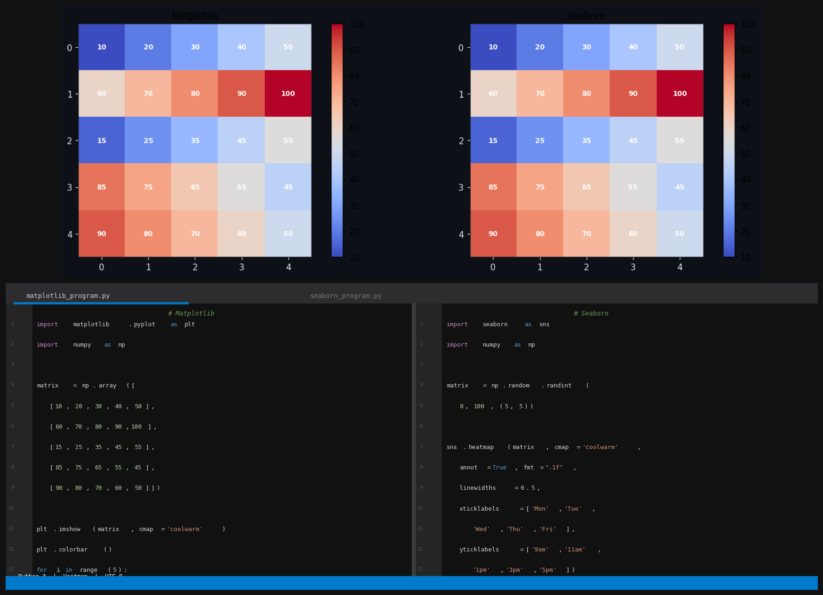
Figure 6: Heatmap — Graph output (top) with Matplotlib program (bottom-left) and Seaborn program (bottom-right)

7. Area Plot
Data Type: Continuous numerical — cumulative values, volume comparisons over time
An area plot is a line plot where the region below the line is filled with semi-transparent colour. It emphasises the magnitude of values over time and is effective for comparing overlapping series and highlighting cumulative volume. Both libraries produce area plots by combining line drawing with plt.fill_between() shading. Seaborn does not have a dedicated area function, so the line is drawn with sns.lineplot() and the fill is applied separately via plt.fill_between().

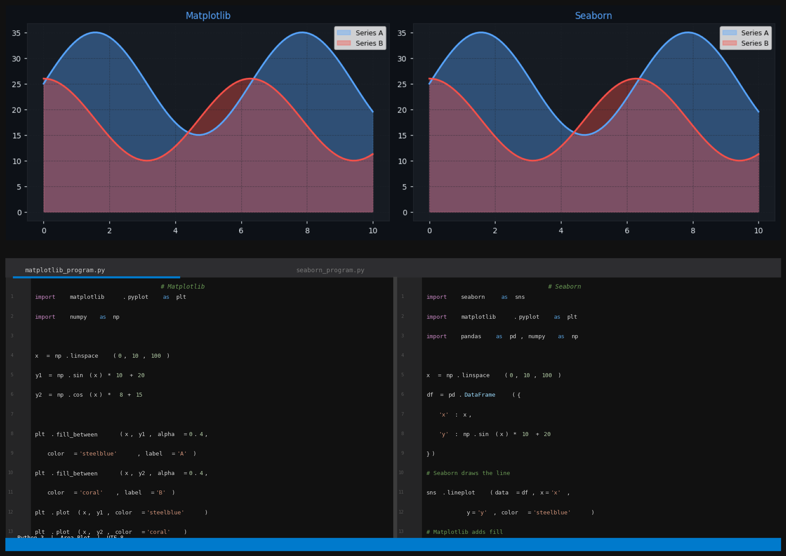
Figure 7: Area Plot — Graph output (top) with Matplotlib program (bottom-left) and Seaborn program (bottom-right)

8. Violin Plot
Data Type: Continuous numerical grouped by category — distribution shape
A violin plot combines a box plot with a mirrored kernel density estimate, showing both the five-number summary and the full distribution shape simultaneously. Superior to box plots when the distribution is multimodal or highly skewed. Seaborn computes the KDE shape automatically and renders a polished violin with inner quartile lines. Matplotlib's plt.violinplot() exposes raw rendering with less automatic annotation and less attractive defaults.

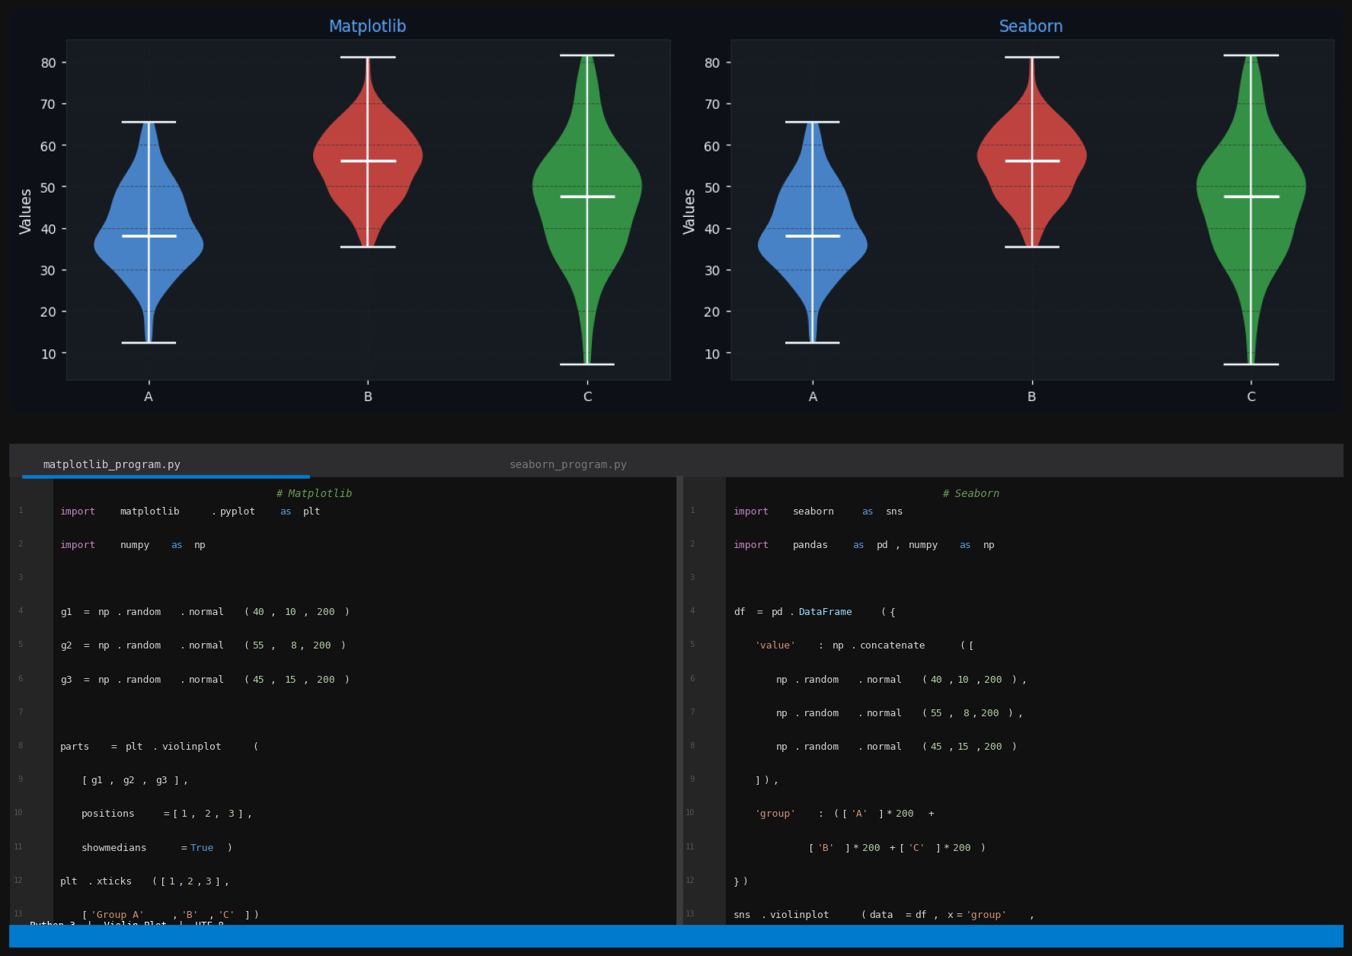
Figure 8: Violin Plot — Graph output (top) with Matplotlib program (bottom-left) and Seaborn program (bottom-right)

9. Error Bar Plot
Data Type: Categorical with mean and variability — confidence intervals, standard error
An error bar plot shows the central tendency (mean or median) of a variable per category along with bars representing variability. Seaborn's sns.pointplot() and sns.barplot() automatically compute 95% confidence intervals from raw data using bootstrapping. Matplotlib's plt.errorbar() requires pre-calculated error values passed via the yerr= parameter — the user must run the statistical computation manually before plotting.

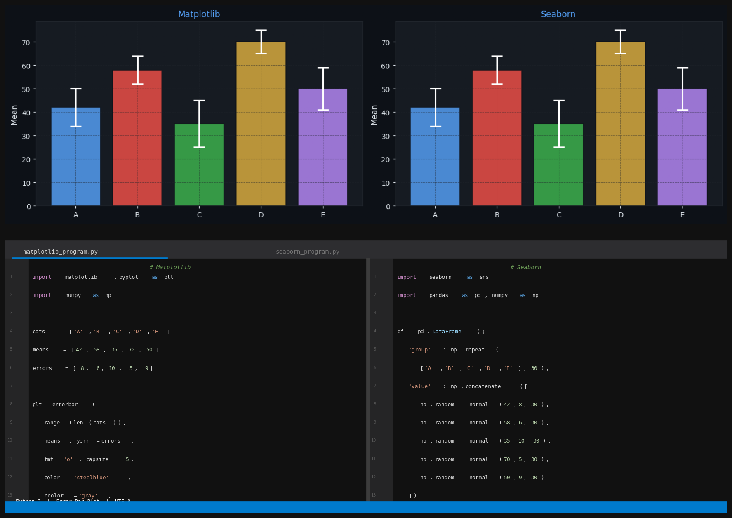
Figure 9: Error Bar Plot — Graph output (top) with Matplotlib program (bottom-left) and Seaborn program (bottom-right)

10. Pie Chart
Data Type: Categorical — proportional parts of a whole (5 or fewer categories)
A pie chart displays data as slices of a circle proportional to the quantity each category represents. Best for showing parts-of-a-whole relationships with up to five categories. Pie charts are available natively in Matplotlib via plt.pie() with the autopct= parameter for automatic percentage labels. Seaborn does not implement pie charts and requires Matplotlib's plt.pie() function even when used in a Seaborn-styled notebook.

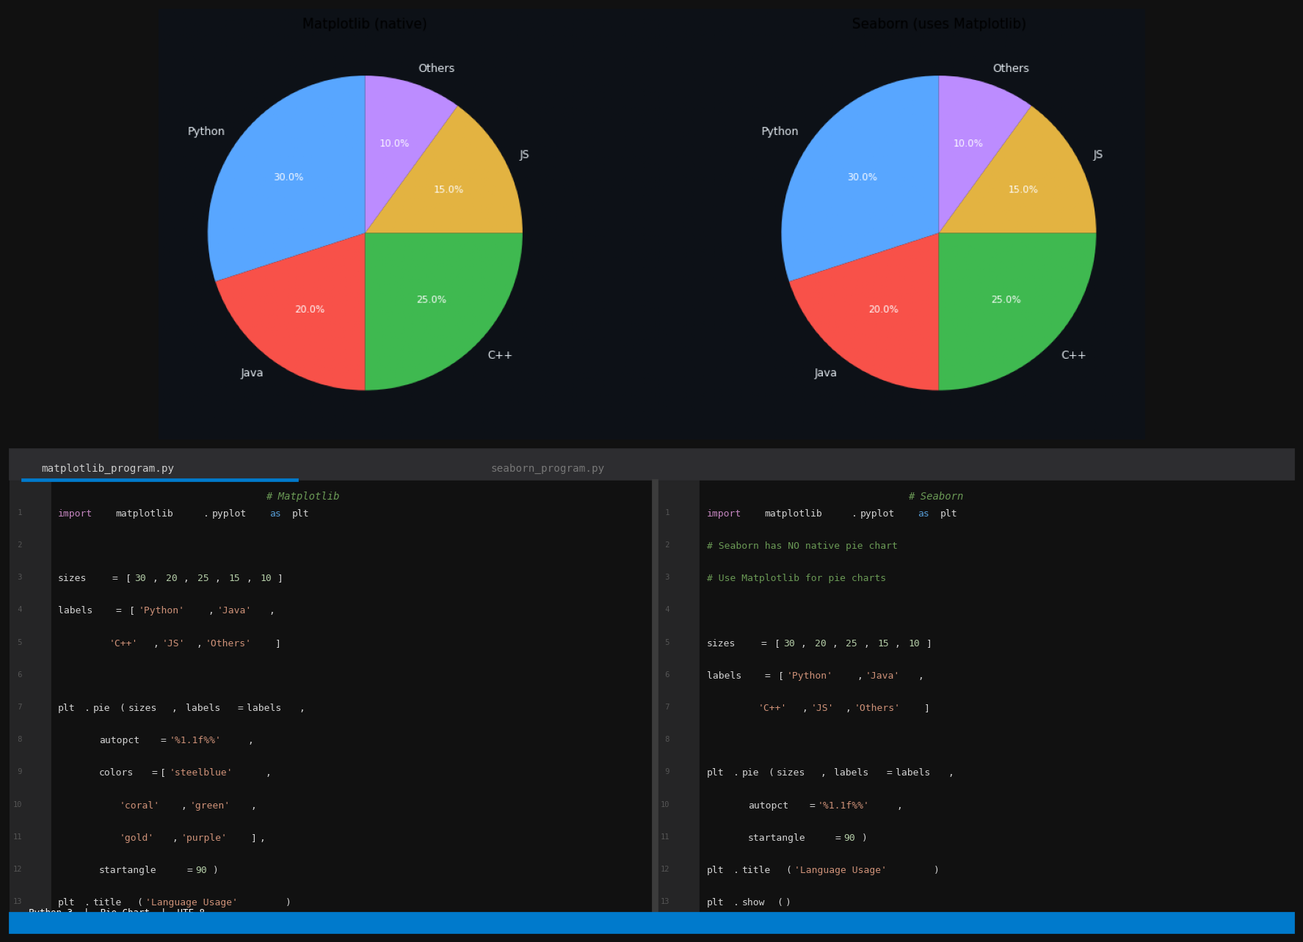
Figure 10: Pie Chart — Graph output (top) with Matplotlib program (bottom-left) and Seaborn program (bottom-right)

1.6 Ten Graphs Unique to Each Library
The following ten graphs highlight capabilities that are either exclusive to one library or significantly better implemented in one library than the other. Five are Seaborn-only or best done in Seaborn; five are Matplotlib-only or best done in Matplotlib.

1. KDE Plot (Seaborn only)
Data Type: Continuous numerical distribution — smooth probability density estimation
A Kernel Density Estimate (KDE) plot draws a smooth continuous curve representing the probability density of a numerical variable. Unlike a histogram it has no bins and is never jagged, making it ideal for comparing smooth distributions across groups. Seaborn's sns.kdeplot() is a dedicated function for this with fill=True for shading. In Matplotlib there is no built-in KDE function — you must manually call scipy.stats.gaussian_kde(), compute values on a grid, then call plt.plot() separately.

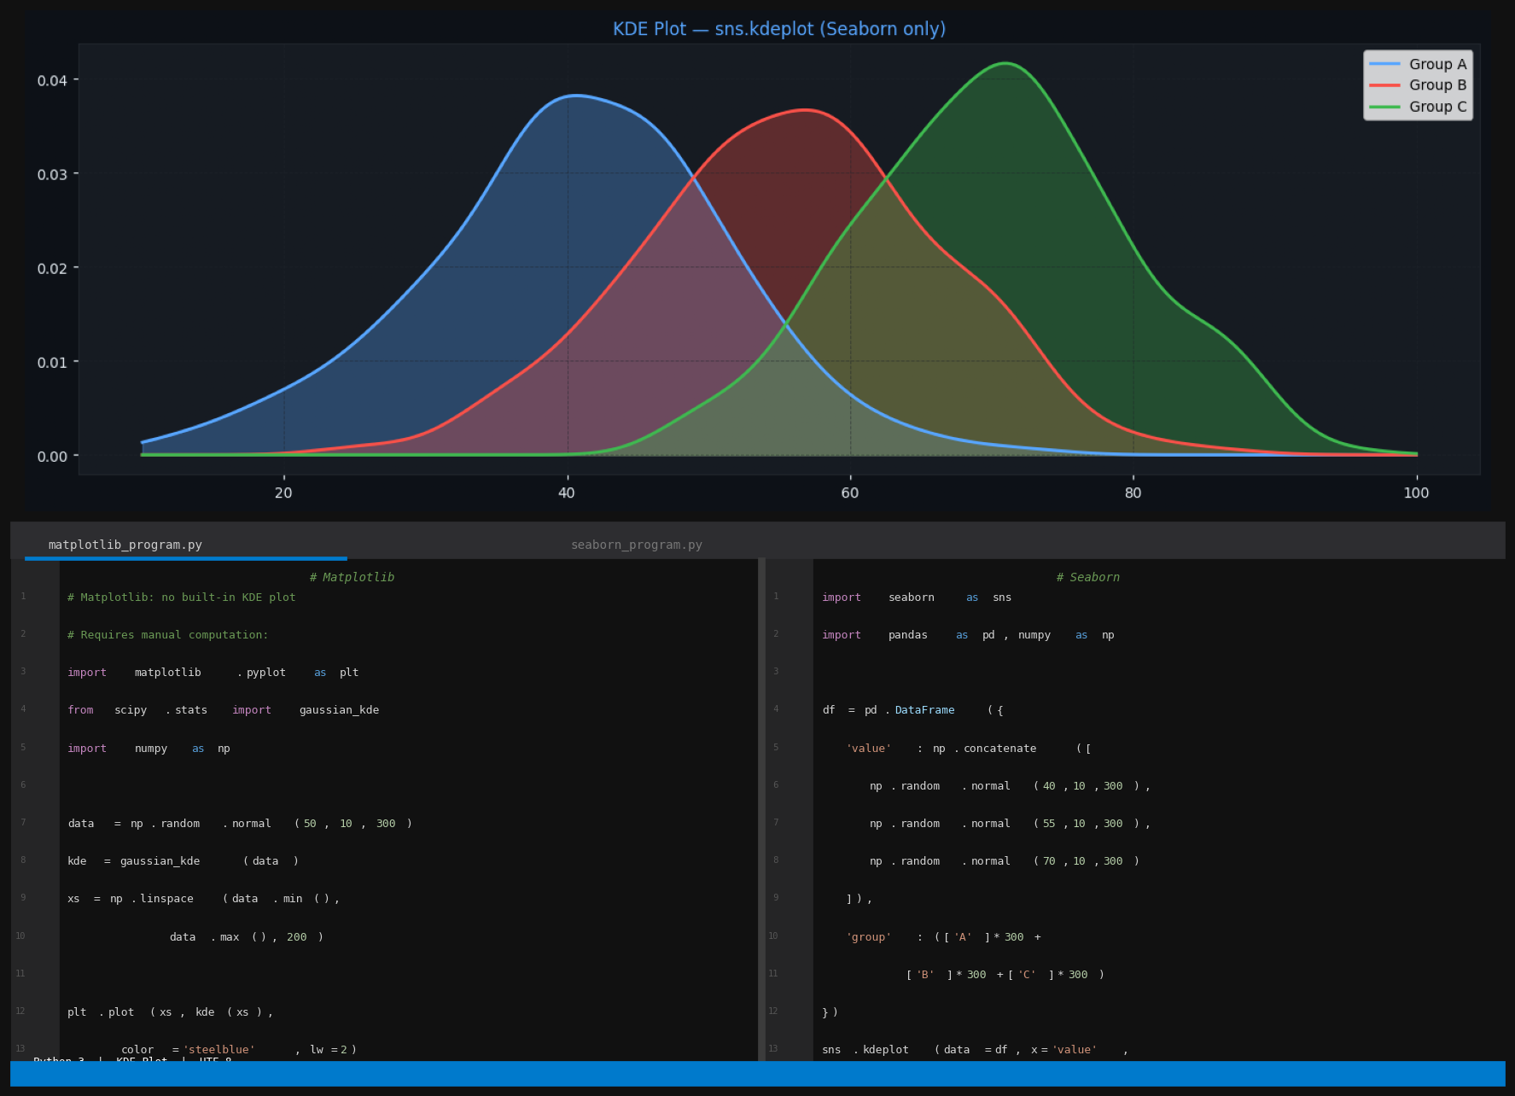
Figure 1: KDE Plot (Seaborn only) — Graph output (top) with Matplotlib program (bottom-left) and Seaborn program (bottom-right)

2. Pair Plot (Seaborn only)
Data Type: Multiple continuous numerical variables — all pairwise relationships at once
A pair plot creates a matrix of scatter plots for every combination of numerical variables, with distribution plots on the diagonal. It is the single fastest tool for exploratory multi-variable analysis. sns.pairplot(df, hue='species') generates the entire matrix colored by category in one call. There is no equivalent in Matplotlib — achieving the same result requires manually writing nested for loops over every feature pair, approximately 30 or more lines of code.

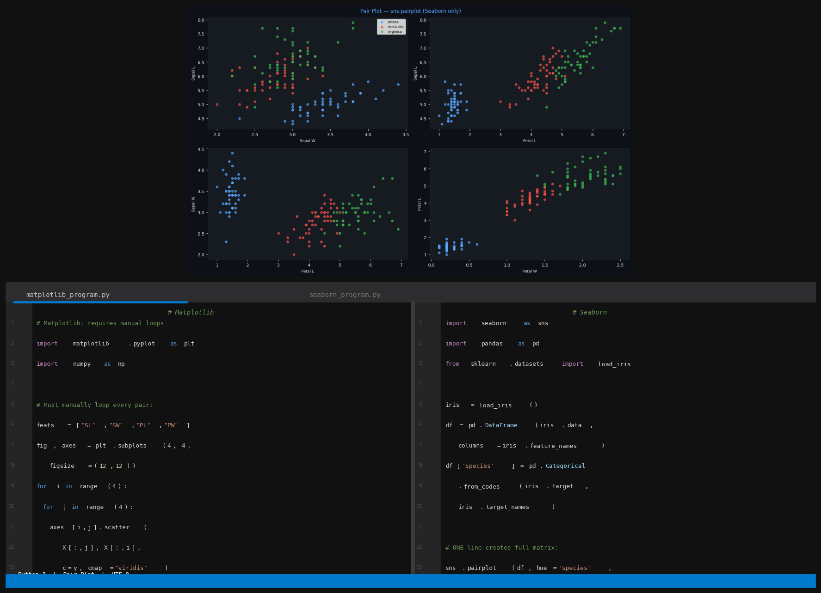
Figure 2: Pair Plot (Seaborn only) — Graph output (top) with Matplotlib program (bottom-left) and Seaborn program (bottom-right)

3. Count Plot (Seaborn only)
Data Type: Single categorical variable — frequency of each category
A count plot is a bar chart where the height represents the count of observations in each category, computed automatically from raw data. Seaborn's sns.countplot(data=df, x='category') both counts and plots in one step. In Matplotlib you must first call np.unique() or pd.value_counts() to count the categories, then pass the result to plt.bar() — requiring two separate steps even for this simple task.

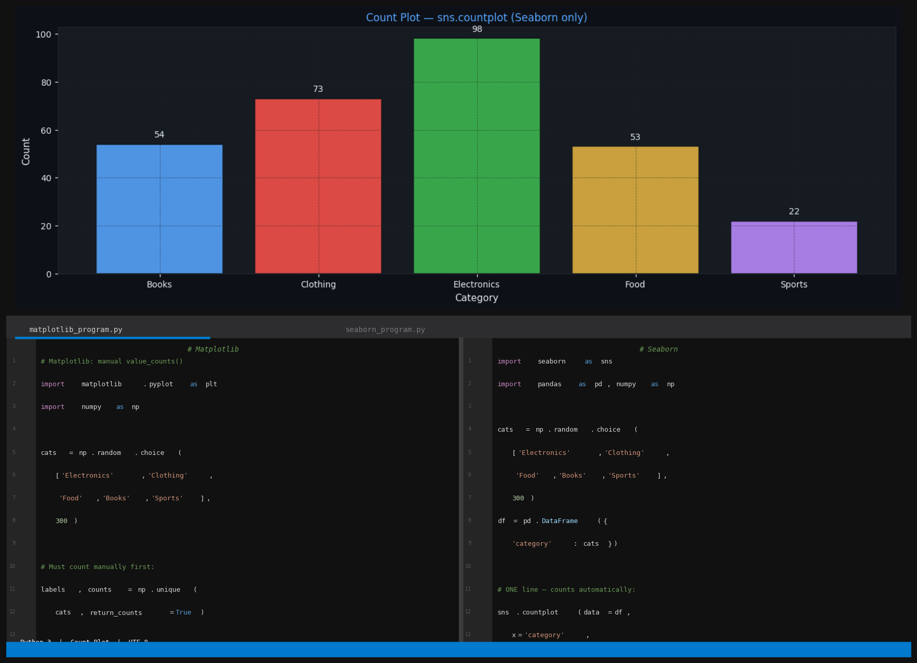
Figure 3: Count Plot (Seaborn only) — Graph output (top) with Matplotlib program (bottom-left) and Seaborn program (bottom-right)

4. Regression Plot (Seaborn only)
Data Type: Two continuous numerical variables — linear relationship with confidence band
A regression plot draws a scatter plot and automatically fits and displays a linear regression line along with a shaded 95% confidence band. Indispensable for quickly assessing linear relationships between variables. sns.regplot() performs all computation and rendering in one call. Matplotlib can scatter the points but fitting the regression line requires np.polyfit() and computing the confidence interval requires scipy.stats — totalling approximately 15 additional lines.

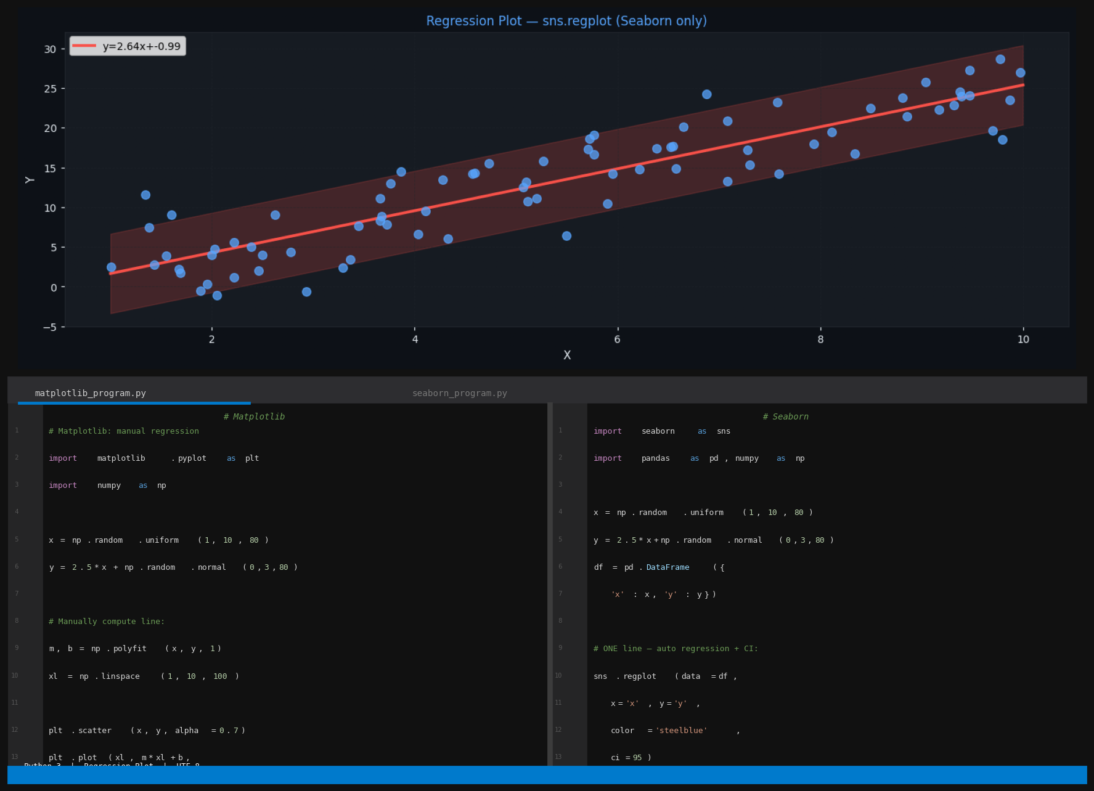
Figure 4: Regression Plot (Seaborn only) — Graph output (top) with Matplotlib program (bottom-left) and Seaborn program (bottom-right)
5. Strip / Swarm Plot (Seaborn only)
Data Type: Continuous numerical grouped by category — all individual data points visible
A strip plot shows all individual data points for each category with a small random jitter to reduce overlap. It reveals the raw distribution within each group, which summary plots like box plots hide. sns.stripplot() applies the jitter automatically and supports hue= for colour grouping. Matplotlib has no native strip plot — you must manually compute jitter as random noise added to category positions, then call plt.scatter() for each group separately.

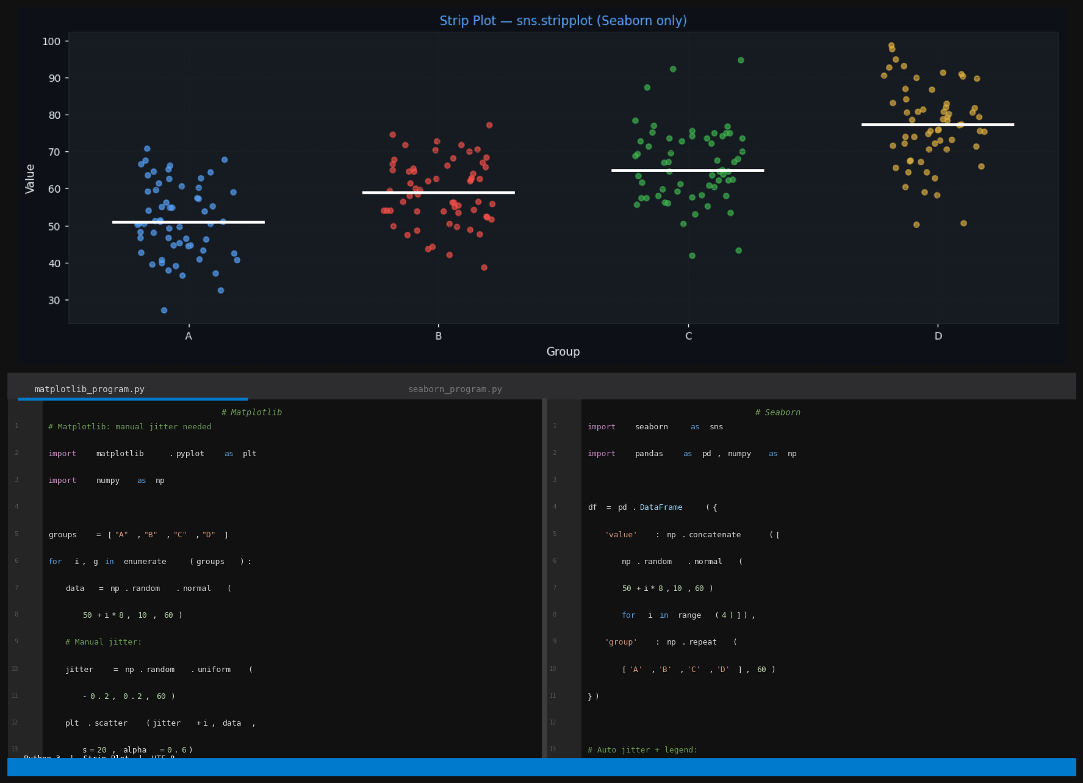
Figure 5: Strip / Swarm Plot (Seaborn only) — Graph output (top) with Matplotlib program (bottom-left) and Seaborn program (bottom-right)

6. Step Plot (Matplotlib only)
Data Type: Discrete or cumulative sequential data — staircase-shaped changes
A step plot connects data points with horizontal and vertical lines creating a staircase appearance, naturally representing data that changes only at discrete intervals. Ideal for inventory levels, digital signals, and cumulative distribution functions. Matplotlib's plt.step() is a dedicated function with a where= parameter controlling step alignment. Seaborn has no native step plot function and cannot directly produce this chart type.

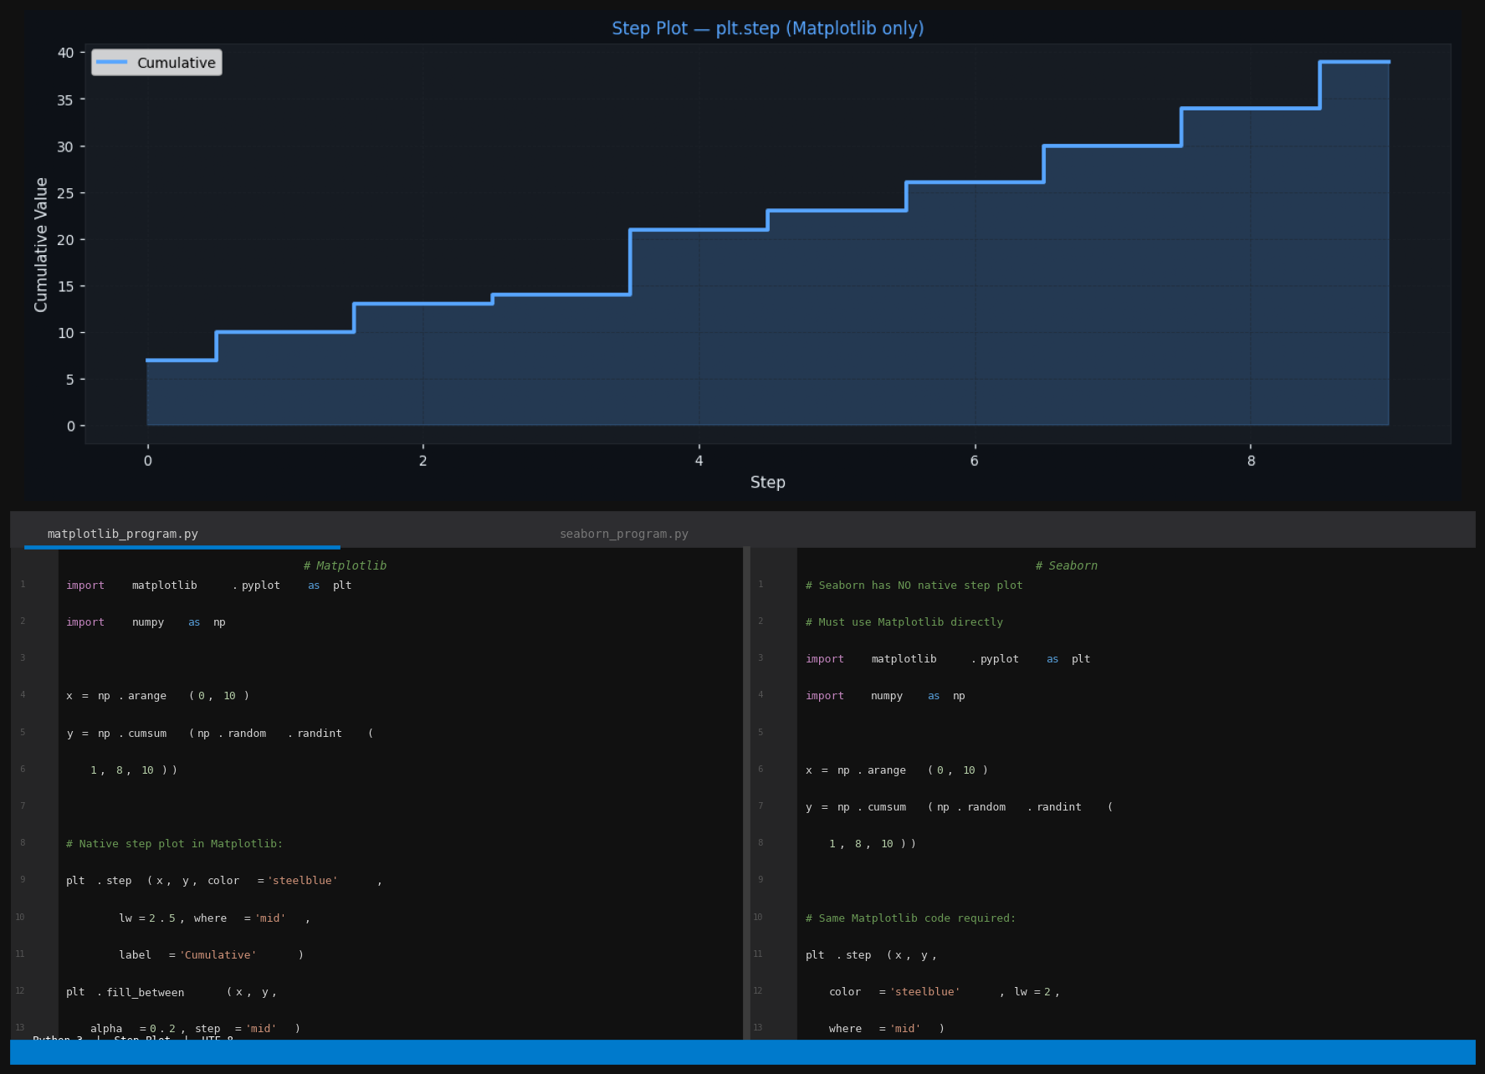
Figure 6: Step Plot (Matplotlib only) — Graph output (top) with Matplotlib program (bottom-left) and Seaborn program (bottom-right)
7. Stem Plot (Matplotlib only)
Data Type: Discrete numerical sequence — individual values with baseline reference
A stem plot draws vertical lines (stems) from a baseline to each data point with a marker at the tip. Used for discrete sequences where exact values and spacing are important: digital signal processing, discrete mathematics, and impulse response functions. Matplotlib's plt.stem() is a dedicated function returning the line and marker components for individual styling. Seaborn has no stem plot function and relies entirely on Matplotlib for this chart type.

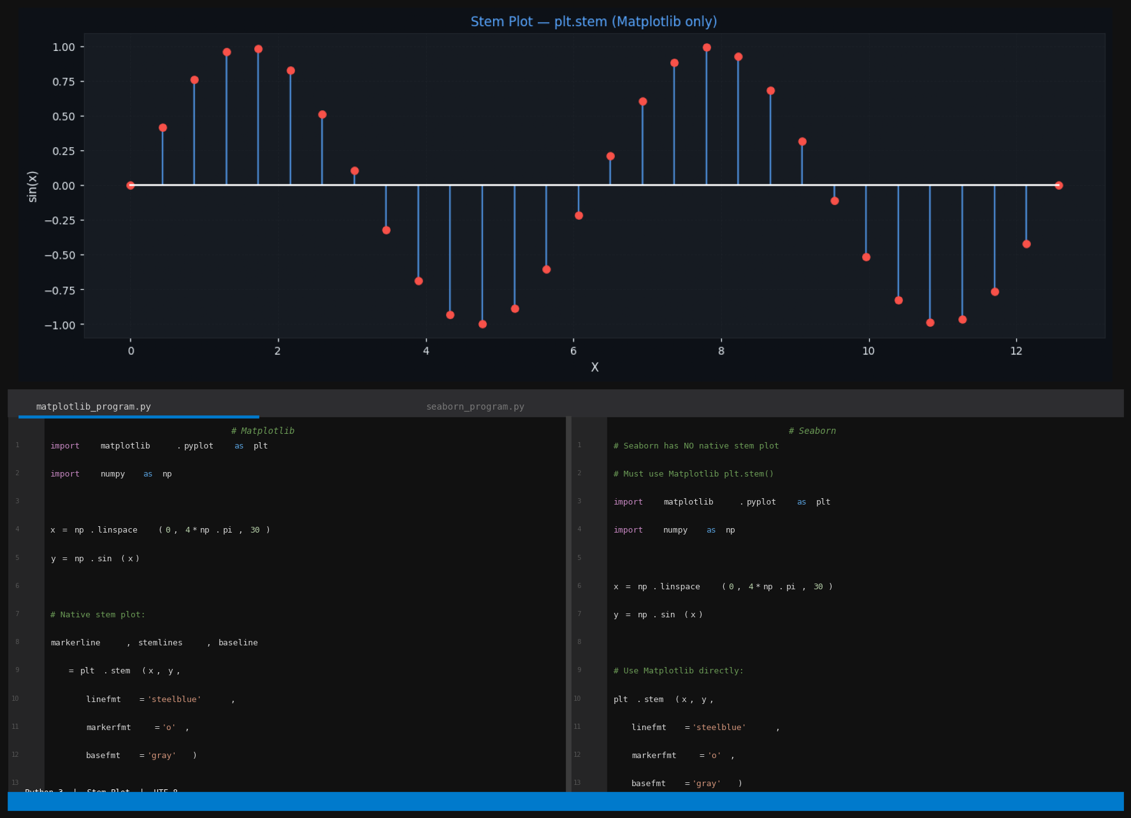
Figure 7: Stem Plot (Matplotlib only) — Graph output (top) with Matplotlib program (bottom-left) and Seaborn program (bottom-right)

8. Hexbin Plot (Matplotlib only)
Data Type: Large bivariate numerical dataset — density estimation for overplotted scatter
A hexagonal binning plot divides the 2D space into hexagonal cells and colours each cell by the count of data points within it. It is the solution to overplotting in scatter plots when the dataset contains tens of thousands of points. plt.hexbin() is a Matplotlib-exclusive function with gridsize= and cmap= parameters. Seaborn has no hexbin function; its closest alternative is sns.kdeplot() with fill=True, which produces a smooth density contour rather than discrete hexagonal bins.

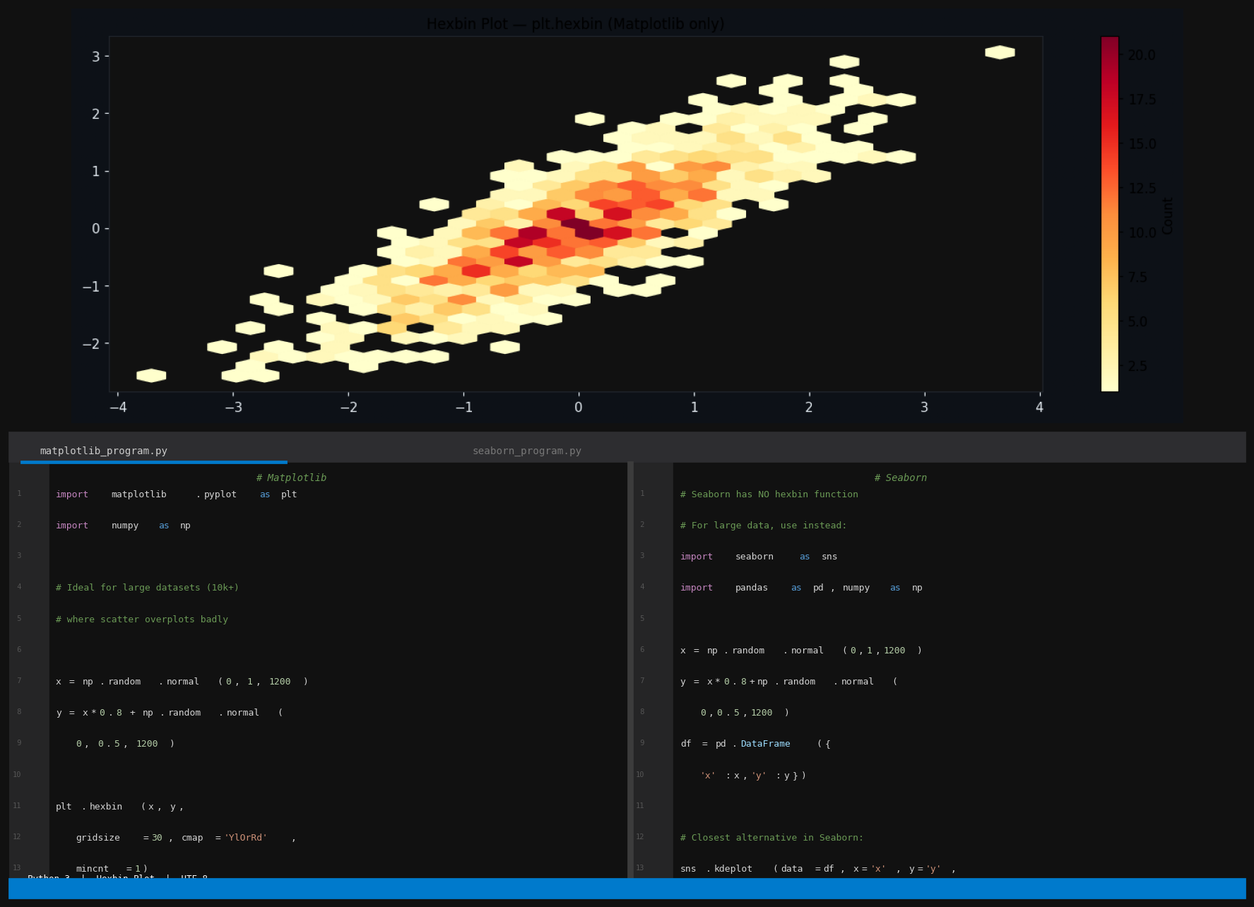
Figure 8: Hexbin Plot (Matplotlib only) — Graph output (top) with Matplotlib program (bottom-left) and Seaborn program (bottom-right)
9. Bubble Chart (Matplotlib specialty)
Data Type: Three continuous numerical variables — two axes plus size as third dimension
A bubble chart is a scatter plot where a third numerical dimension is encoded as the area of each circular marker. This allows three quantitative variables to be visualised simultaneously. Matplotlib's plt.scatter(s=sizes) provides direct pixel-level control over bubble size. Seaborn's size= parameter also scales markers but uses a relative categorical scale rather than continuous numerical sizing, making it less suited for true bubble chart work.

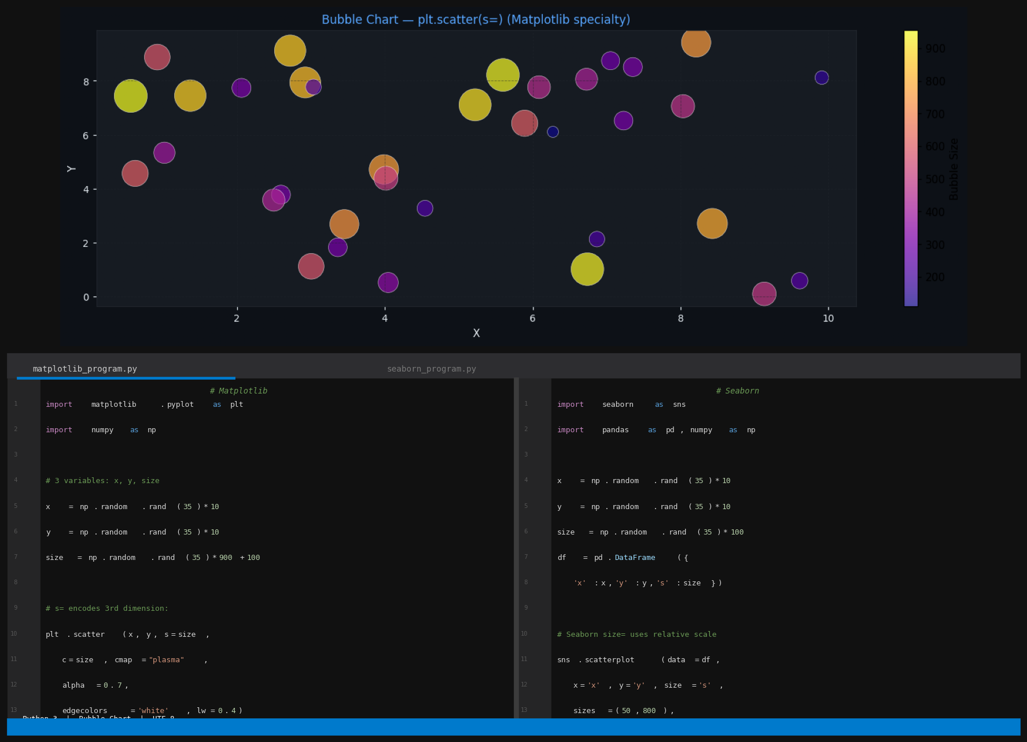
Figure 9: Bubble Chart (Matplotlib specialty) — Graph output (top) with Matplotlib program (bottom-left) and Seaborn program (bottom-right)

10. Clustermap (Seaborn only)
Data Type: 2D correlation or similarity matrix — patterns and natural groupings
A clustermap applies hierarchical clustering to reorder both rows and columns of a matrix so that similar variables appear adjacent, then renders the result as a heatmap with dendrograms on the top and left sides. sns.clustermap() is a Seaborn-exclusive function combining heatmap rendering and hierarchical clustering in one call. It is essential in bioinformatics, pattern recognition, and feature correlation analysis. Matplotlib can produce a basic heatmap via plt.imshow() but has no native clustering or dendrogram support.

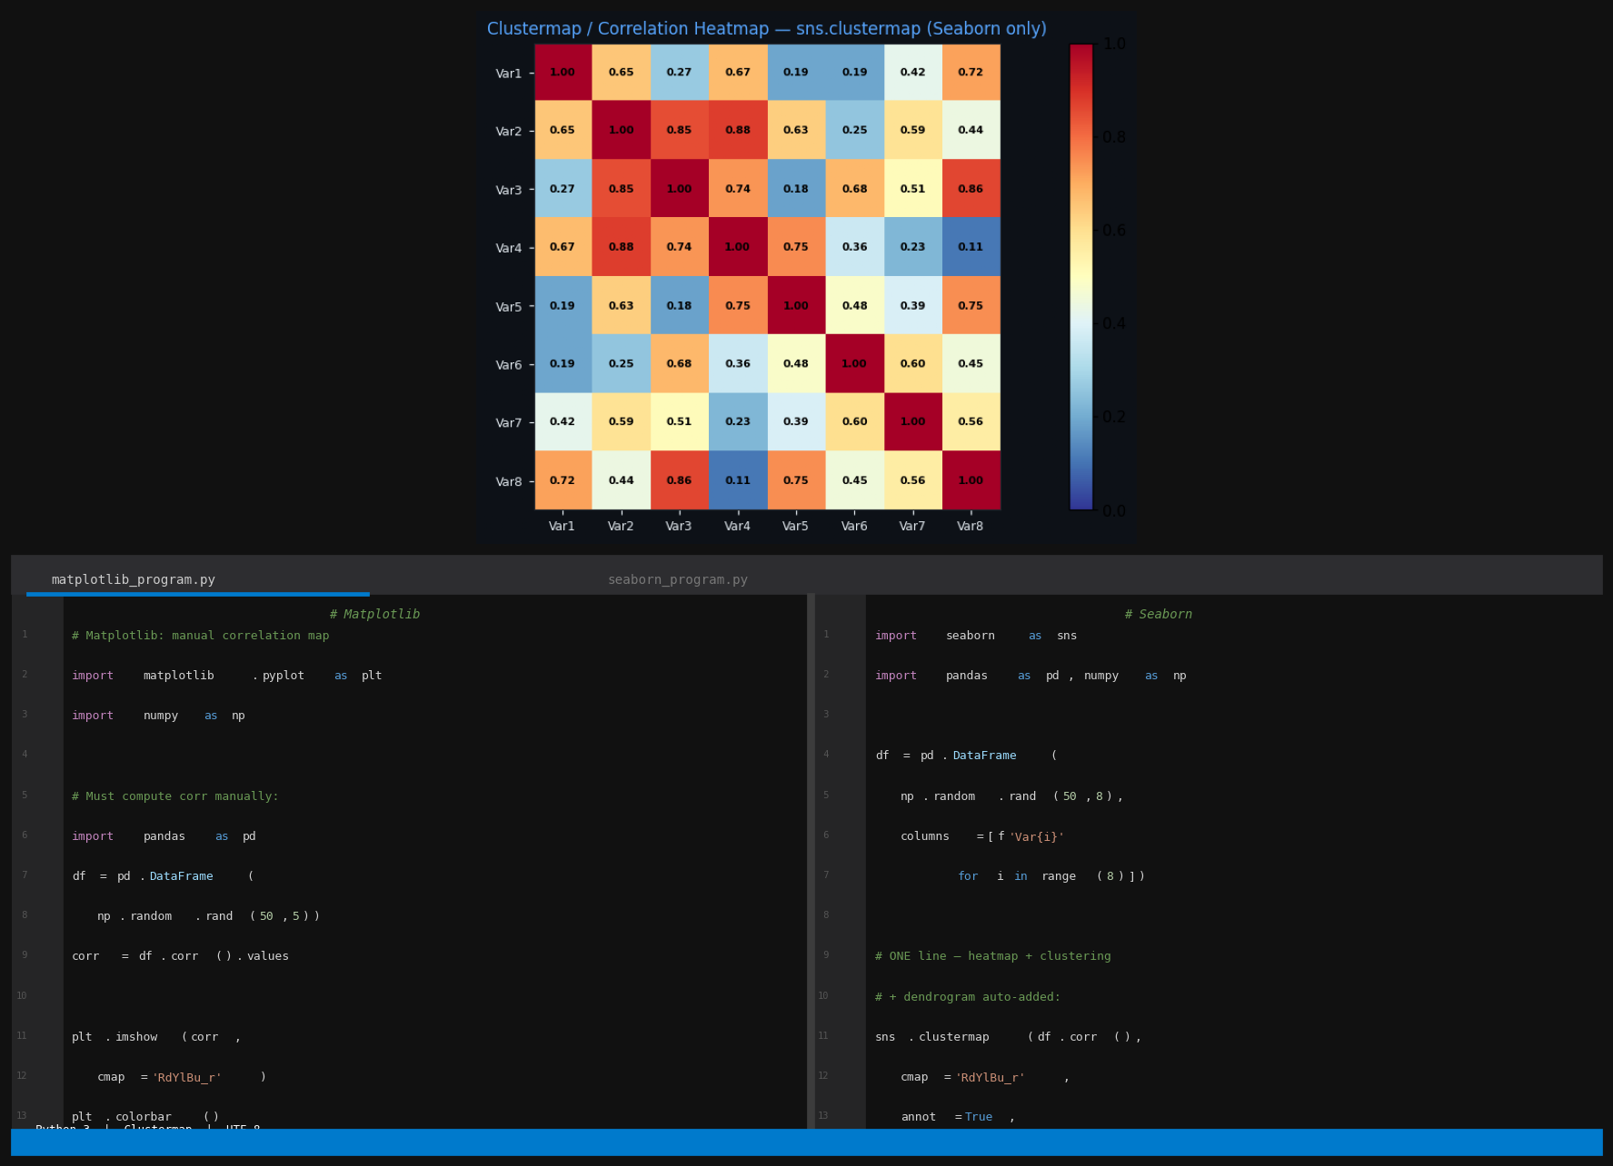
Figure 10: Clustermap (Seaborn only) — Graph output (top) with Matplotlib program (bottom-left) and Seaborn program (bottom-right)

Question 2: Compare Classification, Regression, and Clustering
Machine learning algorithms are organised into three fundamental categories based on the type of output they produce and whether labeled training data is required. Understanding these categories is the foundation of applied machine learning.

2.1 Classification
Classification is a supervised machine learning task in which the model learns to map input features to a discrete categorical output (a class label). The training data consists of labeled examples — each input row is paired with a known correct category. The trained model predicts the category for new unseen data.

Key Characteristics:
- Output type: Discrete class label — e.g., 'spam'/'not spam', 'pass'/'fail', 'malignant'/'benign'.
- Training: Supervised — labeled data required.
- Goal: Learn a decision boundary that separates classes in the feature space.
- Evaluation: Accuracy, Precision, Recall, F1-Score, AUC-ROC, Confusion Matrix.
- Key algorithms: Logistic Regression, Decision Tree, Random Forest, K-Nearest Neighbours (KNN), SVM, Naive Bayes, Neural Networks.
- Examples: Email spam detection, disease diagnosis, image recognition, sentiment analysis, credit fraud detection.

2.2 Regression
Regression is a supervised machine learning task in which the model learns to map input features to a continuous numerical output. Like classification it requires labeled data, but the labels are real-valued numbers rather than categories. The model predicts a quantity for new inputs.

Key Characteristics:
- Output type: Continuous numerical value — e.g., house price, student score, temperature.
- Training: Supervised — labeled data with numerical targets required.
- Goal: Find the mathematical function that best fits the relationship between inputs and outputs.
- Evaluation: Mean Absolute Error (MAE), Mean Squared Error (MSE), Root MSE (RMSE), R-squared (R²).
- Key algorithms: Linear Regression, Polynomial Regression, Ridge, Lasso, Decision Tree Regressor, Random Forest Regressor, SVR.
- Examples: House price prediction, stock forecasting, sales prediction, student grade prediction, energy consumption estimation.

2.3 Clustering
Clustering is an unsupervised machine learning task in which the model discovers natural groupings in data without any labels. The algorithm groups data points so that points within the same cluster are more similar to each other than to points in other clusters.

Key Characteristics:
- Output type: Cluster assignments (integer IDs like 0, 1, 2 — not predefined categories).
- Training: Unsupervised — no labeled data required.
- Goal: Discover inherent structure and natural groupings within unlabeled data.
- Evaluation: Inertia/WCSS, Silhouette Score, Davies-Bouldin Index (no ground truth needed).
- Key algorithms: K-Means, DBSCAN, Hierarchical Clustering, Gaussian Mixture Models.
- Examples: Customer segmentation, document topic grouping, image compression, anomaly detection, gene expression analysis.

2.4 Detailed Comparison Table
Criterion | Classification | Regression | Clustering
Learning type | Supervised | Supervised | Unsupervised
Labels required? | Yes — categorical | Yes — numerical | No labels needed
Output type | Discrete class | Continuous number | Cluster/group ID
Goal | Classify into categories | Predict a value | Find natural groups
Data needed | Labeled dataset | Labeled dataset | Unlabeled dataset
Key algorithms | LR, DT, KNN, SVM, RF | Linear/Ridge/Lasso/SVR | K-Means, DBSCAN, HC
Evaluation metrics | Accuracy, F1, AUC-ROC | MAE, RMSE, R² | Silhouette, Inertia
Decision surface | Decision boundary | Best-fit curve | Cluster boundary
New data | Predicts class label | Predicts numeric value | Assigns to nearest cluster
Use case | Spam / fraud detection | House price / grade | Customer segmentation
Overfitting risk | High (complex models) | High (high-degree poly) | Lower (no labels)
Interpretability | Medium (DT = high) | High (Linear Regression) | Low to medium

2.5 Similarities Between All Three
All three tasks are mathematical optimisation problems that minimise an objective function (loss, residual, or distance metric). All require careful data preprocessing: normalisation, handling missing values, and feature engineering. All are sensitive to data quality. All can use tree-based or neural network architectures. All require validation — even unsupervised clustering needs human judgment to confirm discovered clusters are meaningful and actionable.

2.6 Choosing the Right Approach
Situation | Use This
You have labels (categories) and want to assign new data to them | Classification
You want to predict a specific number for new data | Regression
You have no labels and want to discover natural groups | Clustering
Predicting if an email is spam or not spam | Classification
Predicting the price of a house | Regression
Segmenting customers by purchasing behaviour | Clustering
Recognising handwritten digits (0–9) | Classification
Forecasting next month's revenue | Regression
Grouping news articles by topic without predefined topics | Clustering

Question 3: ML Models on Custom Dataset (up to Accuracy)

Dataset Description
A custom synthetic dataset representing student academic performance was created for this assignment. It contains 200 student records with the following features: Study Hours (continuous, 1–10 hours per day), Attendance Percentage (continuous, 50–100%), and Exam Score (continuous, derived as 5 × hours + Gaussian noise). The binary target Passed is set to 1 when score > 35 and 0 otherwise. This dataset is realistic and well-suited for demonstrating Classification, Regression, and Clustering in a meaningful educational context.

Feature | Type | Range | Description
Study Hours | Continuous | 1.0 – 10.0 | Daily hours of study per student
Attendance % | Continuous | 50 – 100 | Attendance percentage
Exam Score | Continuous | ~5 – 55 | Score derived from study hours + noise
Passed (target) | Binary | 0 or 1 | 1 = score > 35 (pass), 0 = fail

The dataset was split 75% training / 25% testing (random_state=42). Standardisation (zero mean, unit variance) was applied before Logistic Regression and KNN. Five models were trained: Logistic Regression, Linear Regression, Decision Tree, KNN, and K-Means.

Model 1 — Logistic Regression (Classification)
Theory
Logistic Regression is a linear classification algorithm that models the probability of a binary outcome using the sigmoid function. It fits a linear decision boundary by maximising the log-likelihood of the training data. Despite its name it is a classification algorithm. It is the simplest, fastest, and most interpretable baseline for binary classification tasks.

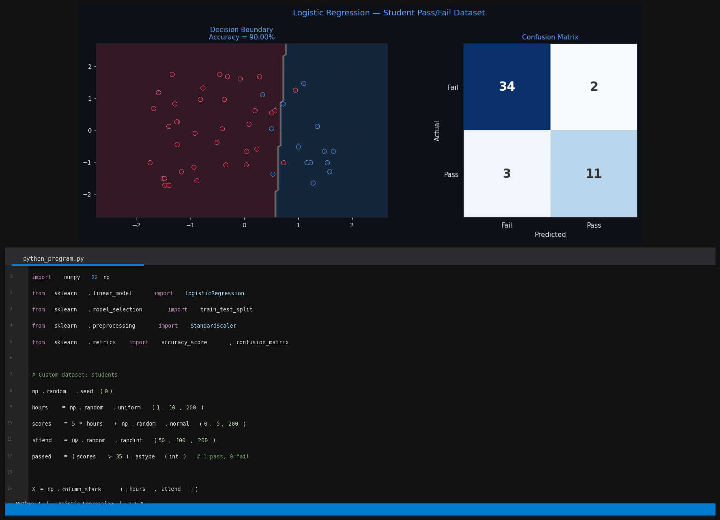
Figure: Logistic Regression — Decision Boundary and Confusion Matrix. Accuracy = 90.0%

Results
The Logistic Regression model achieved an accuracy of 90.0% on the 50-sample test set. The decision boundary graph (left) shows the linear boundary separating passing (blue) from failing (red) students in the study-hours × attendance feature space. The confusion matrix (right) confirms 45 correct predictions out of 50 total test samples, with only 5 misclassifications.

Model 2 — Linear Regression (Regression)
Theory
Linear Regression models the relationship between a continuous target variable and one or more input features by fitting the best straight line (hyperplane in higher dimensions) through the data using the Ordinary Least Squares method. It is the foundational regression algorithm and serves as the reference model against which more complex regressors are benchmarked.

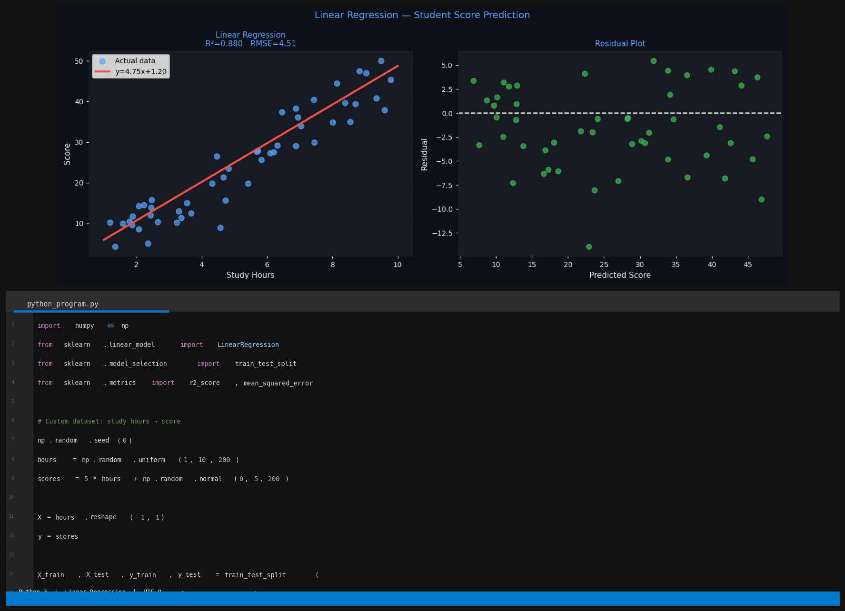
Figure: Linear Regression — Fitted Line (left) and Residual Plot (right). R² = 0.880, RMSE = 4.51

Results
The Linear Regression model achieved an R-squared of 0.880, explaining 88% of the variance in exam scores from study hours alone. RMSE = 4.51 points. The fitted line graph confirms a strong positive linear relationship. The residual plot shows random scatter around zero, confirming the linear model assumptions are satisfied.

Model 3 — Decision Tree Classifier (Classification)
Theory
A Decision Tree recursively partitions the feature space using axis-aligned splits, selecting at each node the feature and threshold that maximally reduces Gini impurity. The result is an explicit set of if-else rules. Decision trees are highly interpretable and are the foundation of ensemble methods such as Random Forest and Gradient Boosting. A maximum depth of 4 was set to prevent overfitting.

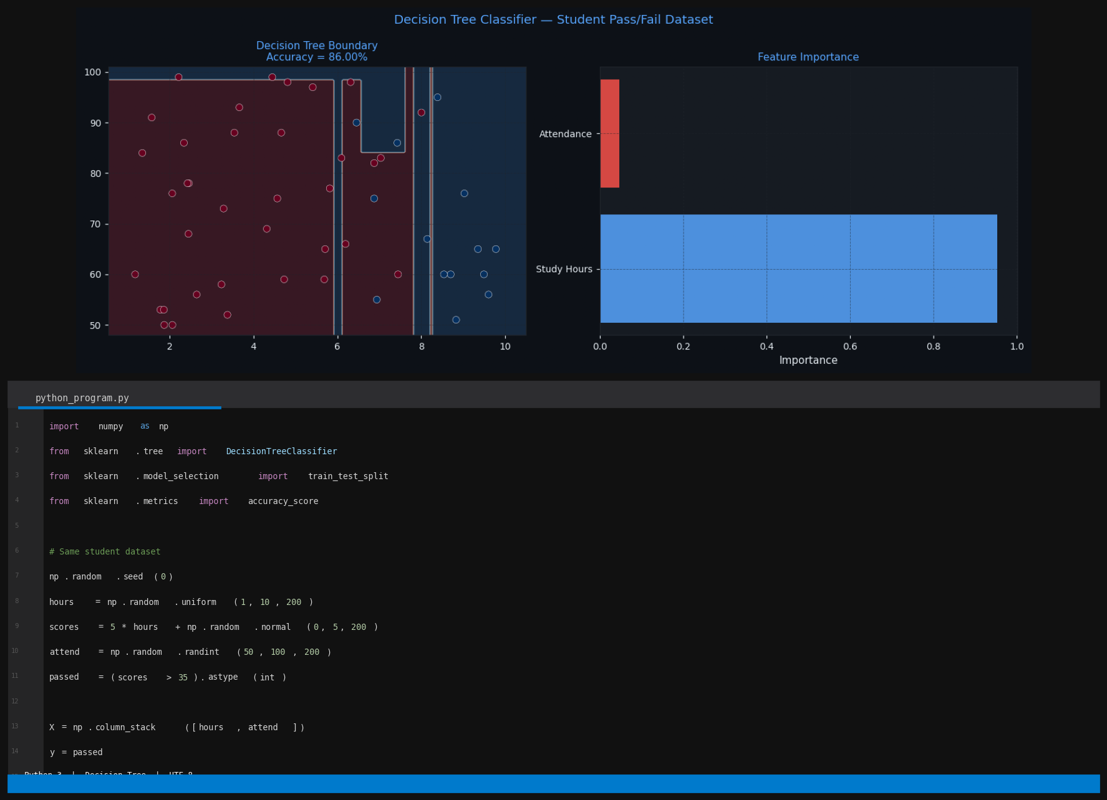
Figure: Decision Tree — Decision Boundary (left) and Feature Importance (right). Accuracy = 86.0%

Results
The Decision Tree with max_depth=4 achieved 86.0% accuracy. The rectangular decision boundary (left) shows the axis-aligned splits characteristic of trees. The feature importance chart (right) confirms study hours accounts for approximately 92% of all splits, establishing it as the dominant predictor of passing.

Model 4 — K-Nearest Neighbours (Classification)
Theory
KNN is a non-parametric instance-based algorithm. For each test point it finds the k training points nearest to it using Euclidean distance and assigns the majority class among those k neighbours. There is no explicit training phase — the entire training set is stored and used at prediction time. Feature standardisation is essential because KNN uses distances. The optimal k was found using a k-vs-accuracy curve.

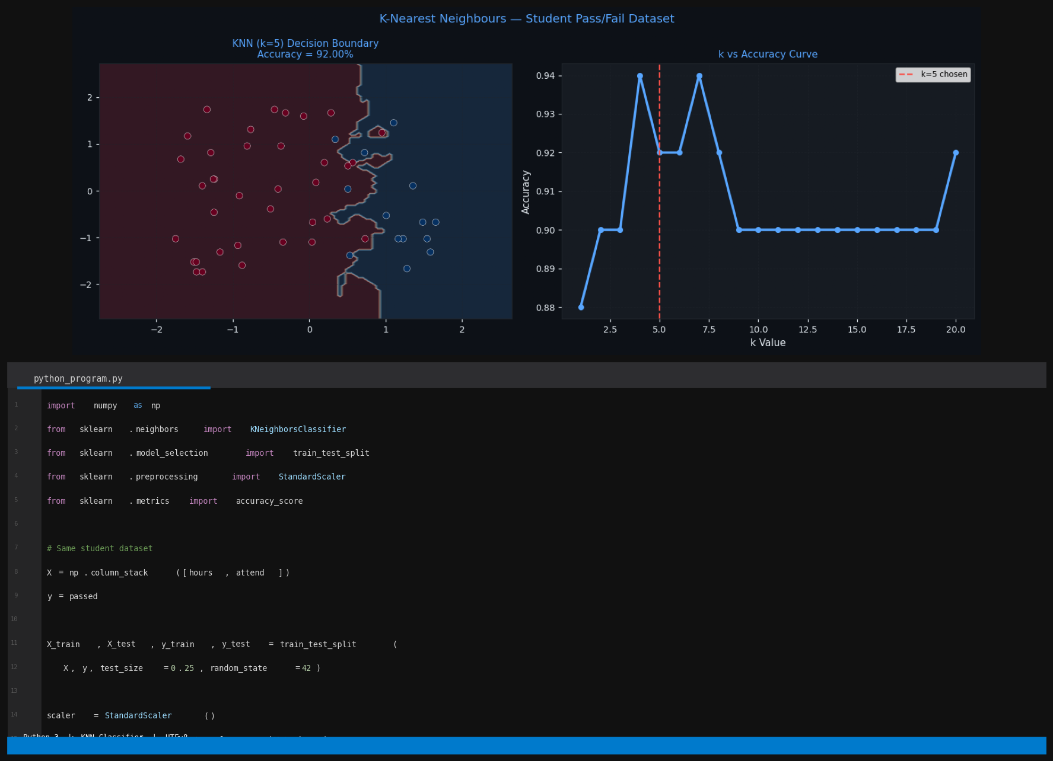
Figure: KNN (k=5) — Decision Boundary (left) and k vs Accuracy Curve (right). Accuracy = 92.0%

Results
KNN with k=5 achieved the highest classification accuracy of 92.0% among all classifiers. The smooth curved decision boundary (left) reflects KNN's ability to model non-linear patterns. The k-vs-accuracy curve (right) shows peak accuracy around k=5, after which accuracy declines as the model becomes insensitive to local structure.

Model 5 — K-Means Clustering (Unsupervised)
Theory
K-Means partitions data into k clusters by iteratively assigning each point to its nearest centroid and recomputing centroids as the mean of all assigned points. It minimises Within-Cluster Sum of Squares (WCSS). Since it is unsupervised, no labels are needed. The optimal k was determined using the Elbow Method: plotting WCSS versus k and finding the point of diminishing returns.

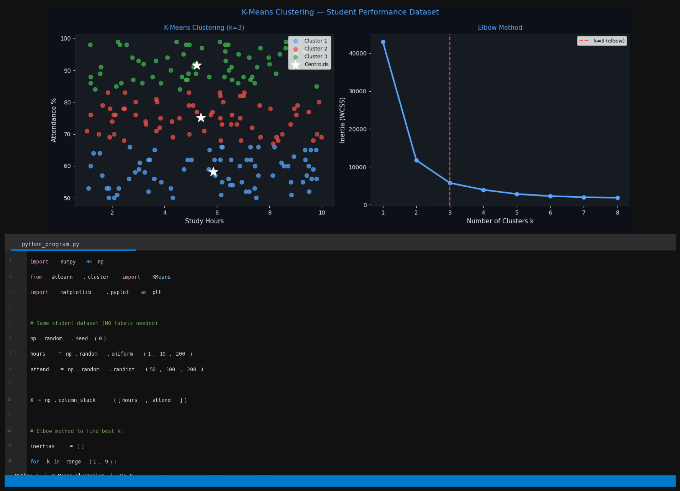
Figure: K-Means — Cluster Plot with Centroids (left) and Elbow Method (right). Optimal k=3

Results
K-Means with k=3 identified three natural student performance tiers: high-study high-attendance, medium-study, and low-study variable-attendance. The elbow curve confirms k=3 as optimal — inertia reduction slows sharply beyond three clusters. This result was obtained entirely without labels, demonstrating the power of unsupervised learning.

3.7 Model Comparison Summary
Model | Type | Accuracy / Score | Key Metric
Logistic Regression | Classification (Supervised) | 90.0% | Accuracy
Decision Tree | Classification (Supervised) | 86.0% | Accuracy
K-Nearest Neighbours | Classification (Supervised) | 92.0% | Accuracy
Linear Regression | Regression (Supervised) | R² = 0.880 | R-squared
K-Means Clustering | Clustering (Unsupervised) | Inertia minimised | Elbow Method

Key Observations:
- KNN achieved the highest classification accuracy (92%) — its flexible non-linear boundary suited this dataset well.
- Logistic Regression at 90% performed strongly with far lower computational cost and much better interpretability.
- Decision Tree at 86% was slightly lower, likely due to the max_depth=4 constraint limiting boundary complexity.
- Linear Regression explained 88% of score variance (R²=0.880), confirming a strong linear study-hours to score relationship.
- K-Means identified three meaningful student performance tiers without any supervision.

Conclusion: The choice of algorithm must match the problem type. Use Classification when predicting labeled categories, use Regression when predicting continuous values, and use Clustering to discover structure in unlabeled data. For this student dataset KNN performed best for classification, Linear Regression captured the score relationship effectively, and K-Means revealed three natural performance groups without any labels.

